**REPORT FOR DIFFERENTIAL EVOLUTION AND CROSS ENTROPY METHOD IMPROVED VERSION ON DIFFERENT TEST FUNCTIONS**

**Table 1: Statistics on results given by DE and CEM on Sphere Function with 2 and 10 dimensions**

|  |  |  |
| --- | --- | --- |
| **Popsize N/λ** | **DE-Sphere,d=2** | **CEM-Sphere,d=2** |
| 32 | 0.0(0.0) | 0.00597(0.00385) |
| 64 | 0.0(0.0) | 0.00222(0.00253) |
| 128 | 0.0(0.0) | 0.00087(0.00084) |
| 256 | 0.0(0.0) | 0.00024(0.00022) |
| 512 | 0.0(0.0) | 7e-05(6e-05) |
| 1024 | 0.0(0.0) | 7e-05(8e-05) |



|  |  |  |
| --- | --- | --- |
| **Popsize N/λ** | **DE-Sphere,d=10** | **CEM-Sphere,d=10** |
| 32 | 0.0(0.0) | 0.42347(0.15829) |
| 64 | 0.0(0.0) | 0.29951(0.05964) |
| 128 | 0.0(0.0) | 0.27626(0.03368) |
| 256 | 0.0(0.0) | 0.23536(0.05872) |
| 512 | 0.0(0.0) | 0.18536(0.02902) |
| 1024 | 0.0(0.0) | 0.14883(0.0422) |





**(DE) (CEM)**

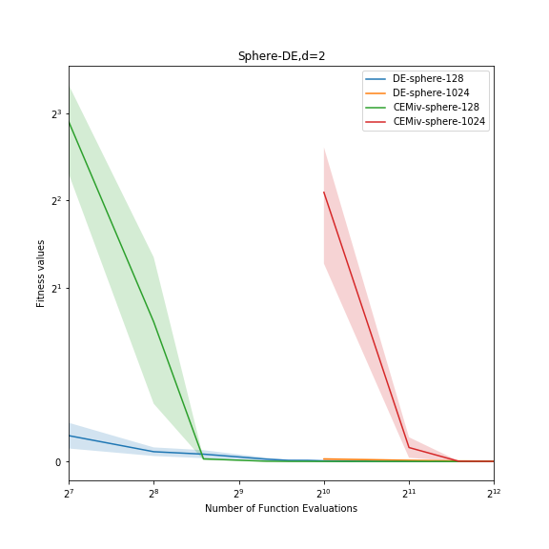

1. **Graph of DE and CEM with Sphere Function and 2 dimensions**

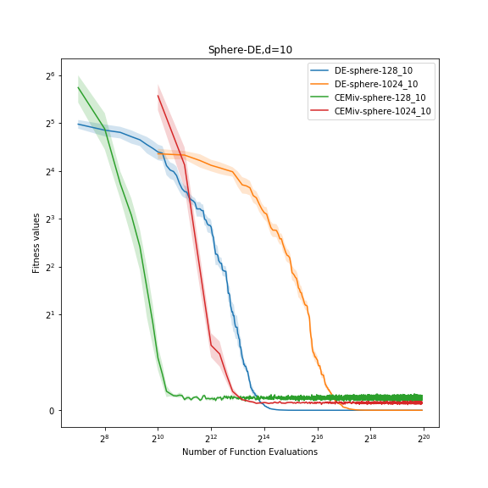

1. **Graph of DE and CEM with Sphere Function and 10 dimensions**

**Table 2: Statistics on results given by DE and CEM on Zakharov Function with 2 and 10 dimensions**

|  |  |  |
| --- | --- | --- |
| **Popsize N/λ** | **DE-zakharov,d=2** | **CEM-zakharov,d=2** |
| 32 | 0.0(0.0) | 0.0065(0.00711) |
| 64 | 0.0(0.0) | 0.00336(0.00322) |
| 128 | 0.0(0.0) | 0.00119(0.00115) |
| 256 | 0.0(0.0) | 0.00036(0.00031) |
| 512 | 0.0(0.0) | 0.00013(0.00012) |
| 1024 | 0.0(0.0) | 0.0001(0.0001) |



|  |  |  |
| --- | --- | --- |
| **Popsize N/λ** | **DE-zakharov,d=10** | **CEM-zakharov,d=10** |
| 32 | 0.0(0.0) | 1.69332(0.61684) |
| 64 | 0.0(0.0) | 1.21712(0.43901) |
| 128 | 0.0(0.0) | 0.97004(0.31074) |
| 256 | 0.0(0.0) | 0.72192(0.18176) |
| 512 | 0.0(0.0) | 0.73489(0.1) |
| 1024 | 0.01354(0.00398) | 0.56194(0.10487) |



**(DE) (CEM)**

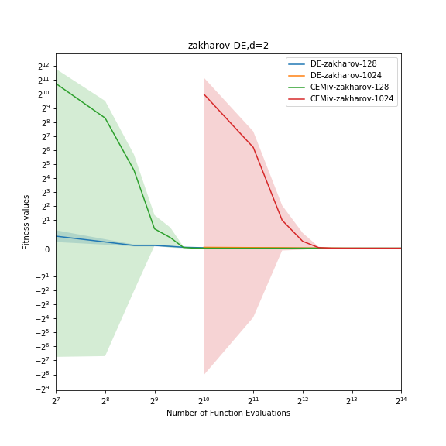

1. **Graph of DE and CEM with Zakharov Function and 2 dimensions**

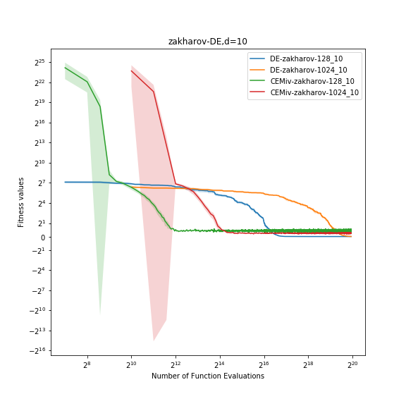

1. **Graph of DE and CEM with Zakharov Function and 10 dimensions**

**Table 3: Statistics on results given by DE and CEM on Rosenbrock Function with 2 and 10 dimensions**

|  |  |  |
| --- | --- | --- |
| **Popsize N/λ** | **DE-Rosenbrock,d=2** | **CEM-Rosenbrock,d=2** |
| 32 | 0.0(0.0) | 0.17155(0.17989) |
| 64 | 0.0(0.0) | 0.06007(0.04044) |
| 128 | 0.0(0.0) | 0.04459(0.03894) |
| 256 | 0.0(0.0) | 0.02118(0.01222) |
| 512 | 0.0(0.0) | 0.00546(0.00625) |
| 1024 | 0.0(0.0) | 0.00421(0.00171) |

|  |  |  |
| --- | --- | --- |
| **Popsize N/λ** | **DE-Rosenbrock,d=10** | **CEM-Rosenbrock,d=10** |
| 32 | 0.0(0.0) | 45.02323(17.95926) |
| 64 | 0.0(0.0) | 39.15314(6.86243) |
| 128 | 0.0(0.0) | 32.67031(7.43) |
| 256 | 0.0(0.0) | 27.28374(4.61569) |
| 512 | 0.0002(5e-05) | 22.36266(4.48565) |
| 1024 | 0.44992(0.03827) | 23.39741(2.86128) |





**(DE) (CEM)**

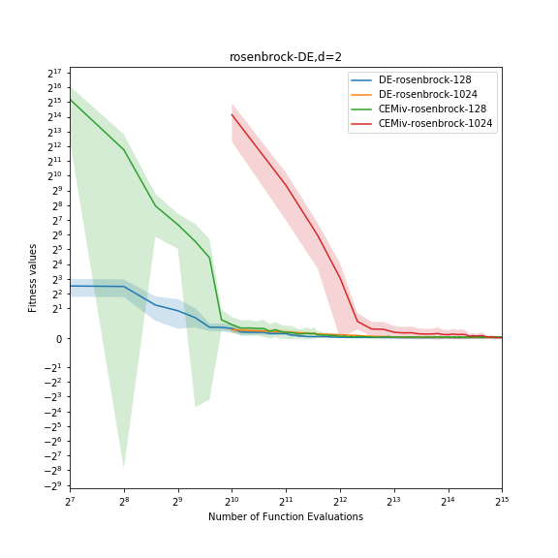

1. **Graph of DE and CEM with Rosenbrock Function and 2 dimensions**

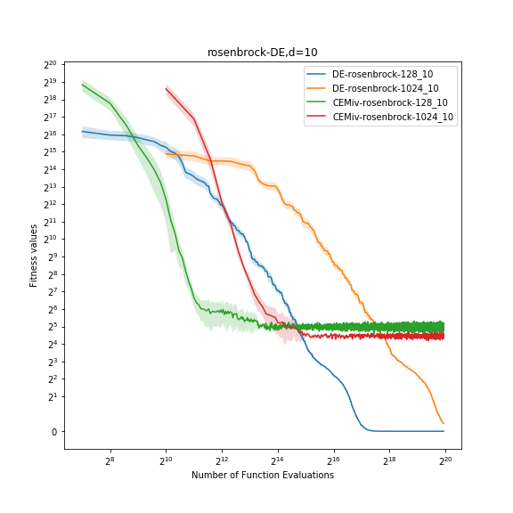

1. **Graph of DE and CEM with Rosenbrock Function and 10 dimensions**

**Table 4: Statistics on results given by DE and CEM on Michalewicz Function with 2 and 10 dimensions**

|  |  |  |
| --- | --- | --- |
| **Popsize N/λ** | **DE-Michalewicz,d=2** | **CEM-Michalewicz,d=2** |
| 32 | -1.8013(0.0) | -1.69593(0.09596) |
| 64 | -1.8013(0.0) | -1.74183(0.05839) |
| 128 | -1.8013(0.0) | -1.78069(0.01858) |
| 256 | -1.8013(0.0) | -1.7901(0.00855) |
| 512 | -1.8013(0.0) | -1.79709(0.00307) |
| 1024 | -1.8013(0.0) | -1.79875(0.00355) |

|  |  |  |
| --- | --- | --- |
| **Popsize N/λ** | **DE-Michalewicz,d=10** | **CEM-Michalewicz,d=10** |
| 32 | -9.63772(0.02068) | -3.68037(0.43684) |
| 64 | -9.66015(0.0) | -4.01524(0.32531) |
| 128 | -9.66015(0.0) | -4.55537(0.3667) |
| 256 | -9.66015(0.0) | -4.84328(0.62876) |
| 512 | -9.66015(0.0) | -4.99113(0.35068) |
| 1024 | -9.25392(0.11207) | -5.04704(0.31658) |



**(DE) (CEM)**

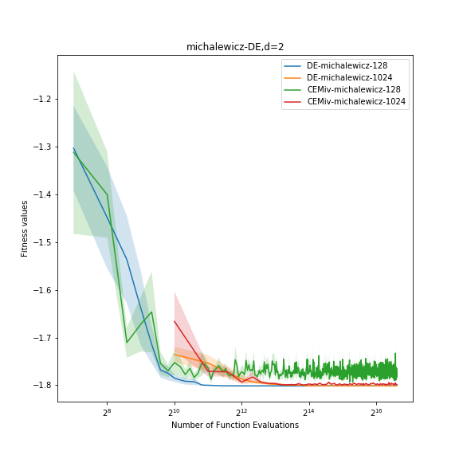

1. **Graph of DE and CEM with Michalewicz Function and 2 dimensions**

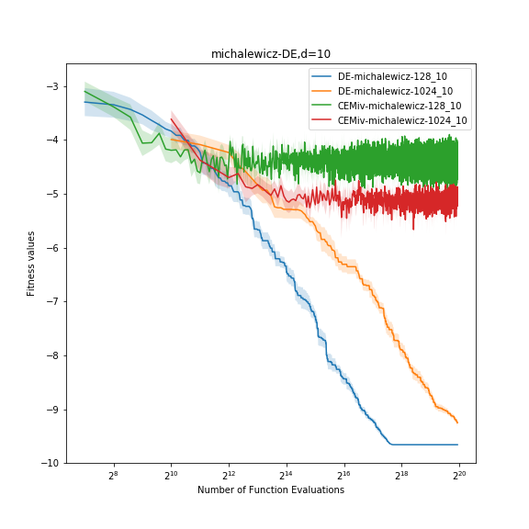

1. **Graph of DE and CEM with Michalewicz Function and 10 dimensions**

**Table 5: Statistics on results given by DE and CEM on Ackley Function with 2 and 10 dimensions**

|  |  |  |
| --- | --- | --- |
| **Popsize N/λ** | **DE-Ackley,d=2** | **CEM-Ackley,d=2** |
| 32 | 0.0(0.0) | 0.37828(0.15764) |
| 64 | 0.0(0.0) | 0.19671(0.15137) |
| 128 | 0.0(0.0) | 0.11609(0.08892) |
| 256 | 0.0(0.0) | 0.03624(0.02538) |
| 512 | 0.0(0.0) | 0.01749(0.00596) |
| 1024 | 0.0(0.0) | 1.98203(5.87023) |

|  |  |  |
| --- | --- | --- |
| **Popsize N/λ** | **DE-Ackley,d=10** | **CEM-Ackley,d=10** |
| 32 | 0.0(0.0) | 2.09254(0.12911) |
| 64 | 0.0(0.0) | 1.61766(0.31065) |
| 128 | 0.0(0.0) | 1.60912(0.13924) |
| 256 | 0.0(0.0) | 1.57104(0.2261) |
| 512 | 0.0(0.0) | 1.31162(0.20394) |
| 1024 | 0.0(0.0) | 1.18873(0.2019) |





**(DE) (CEM)**

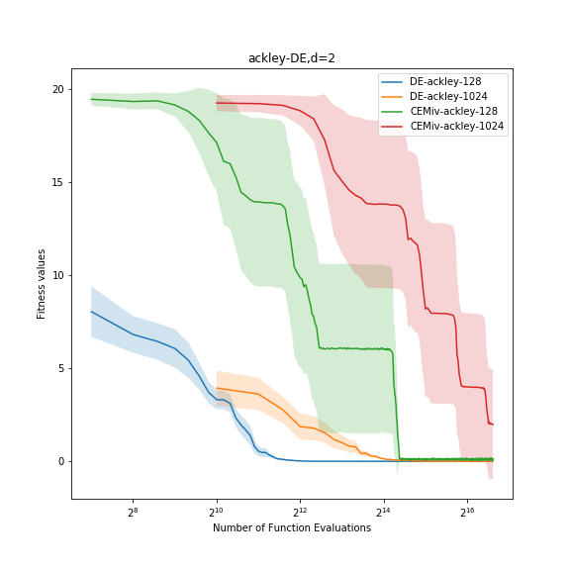

1. **Graph of DE and CEM with Ackley Functions and 2 dimensions**

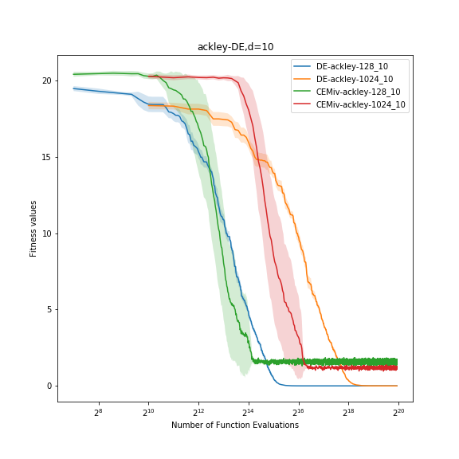

1. **Graph of DE and CEM with Ackley Function and 10 dimensions**

**\*Note:**  Which row in the table has p_value < 0.05 and which element in that row is smaller than the other one will be highlighted.

* **Comments:**
* Based on the results above given by experimenting with Differential Evolution(DE) and Cross-Entropy Method Improved Version (CEM) on solving different test functions, it is easy to consider that DE gives out a better solution with better results than CEM all the time. Moreover, even in challenging cases such as test functions with 10 dimensions, CEM does not converge to the global minimum of all the test functions although DE can deal with those cases very well. However, CEM has a shorter implementation time in comparison with DE, regardless of increasing difficulties in different functions or increasing population size within each test function.
* In conclusion, in the case of using 5 different objective functions with 2 and 10 dimensions, and 6 distinct population sizes, DE has a better performance than CEM.
* **Because of the big size of the file, I have to zip it and** [**here is the link**](https://drive.google.com/drive/folders/17NCaHXk1Tlk0VQel-FfZVo4EgpPcffVT?usp=sharing)